## Overview

The first step to building any webpage is creating a solid structure.

In this activity, you will test your HTML skills to construct your style guide’s structure.

**Note:** You may encounter unfamiliar HTML tags during this activity. Feel free to look up documentation for those tags.

## Tips

* We use the <section> tag to declare high-level containers for a website. They are used to thematically group content. Child elements within a <section> should thematically fit into that section. For example, the color palette section of your style guide will only contain elements that are color palettes.
* The <div> tag is loosely used to create a group of other HTML tags.
* Use the CSS property and value outline: 1px solid red; as a tool to visualize your content. Read more [here](https://www.w3schools.com/cssref/pr_outline.asp) about outline.

## Instructions

**Part 0: Install VS Code Extension**

1. Go to the [Live Server VS Code Extension](https://marketplace.visualstudio.com/items?itemName=ritwickdey.LiveServer) page and download the extension.
2. Click “Install” and confirm that you already have VS Code installed.
3. There will be a browser pop-up prompting you to open the link in another application. Select “yes.”
4. VS Code will open. Click the “Install” button.

You will now be able to view your code in a “live” environment by clicking the “Go Live” button at the bottom of your VS Code window.

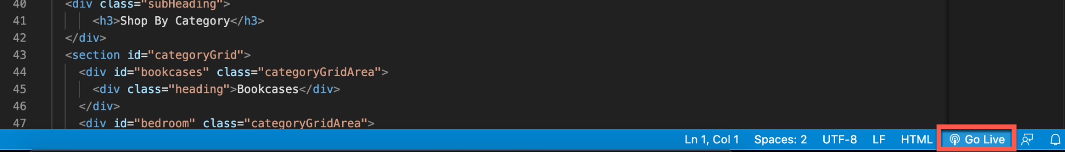

**Part 1: Building Sections**

1. Go to the 17.2 activity .zip on the Google drive, and open index.html.
2. Next, open 17.2-USPS-Style-Guide.xd or the [Figma Resource 17.2-USPS-Styleguide](https://www.figma.com/file/MC3t4WcNMFxC1bowcjKGZo/17.2-01-USPS-Styleguide). You will be creating five section tags in your HTML file to recreate this style guide:
   * A header section containing a single image
   * A color palette section
   * A typography guide section
   * A section containing reusable UI elements
   * A logo section
3. Add a <section> tag with the class header as the first element nested inside the <body> tag.

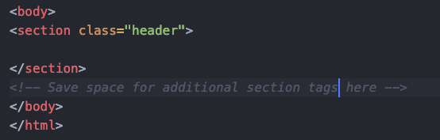

1. Next, create the remaining four sections with the following respective classes in order:
   * colorPalette, typography, uiElements, and imagery

**Part 2: The colorPalette Section**

1. Inside the colorPalette section, add the following tags and values.
2. Add an <h1> tag with the id of pageTopic.
   * Type “USPS Style Guide” between the opening and closing tags.
3. Add an <h2> tag with a class of sectionHead.
   * Type “Primary Colors” between the opening and closing tags.
4. Add a <div> tag with the class of colorContainer.
   * Create two more <div>s within this one.
   * Give the first <div> tag the classes swatch and darkBlue. You can add multiple classes like this:

| <div class="class1 class2">...</div> |
| --- |

* + Give the second <div> tag the class hexCode and type “#333366” between the opening and closing tags.

1. Repeat Part 2, Step 4 with the following values for the **second** class name in the **first** nested <div> tag, and the following text for the **second** nested <div> tag.

| darkGrey | #545454 |
| --- | --- |
| lightGrey | #E3E3E3 |
| white | #FFFFFF |
| lightBlue | #13A0F6 |

Your HTML should look like the following:  
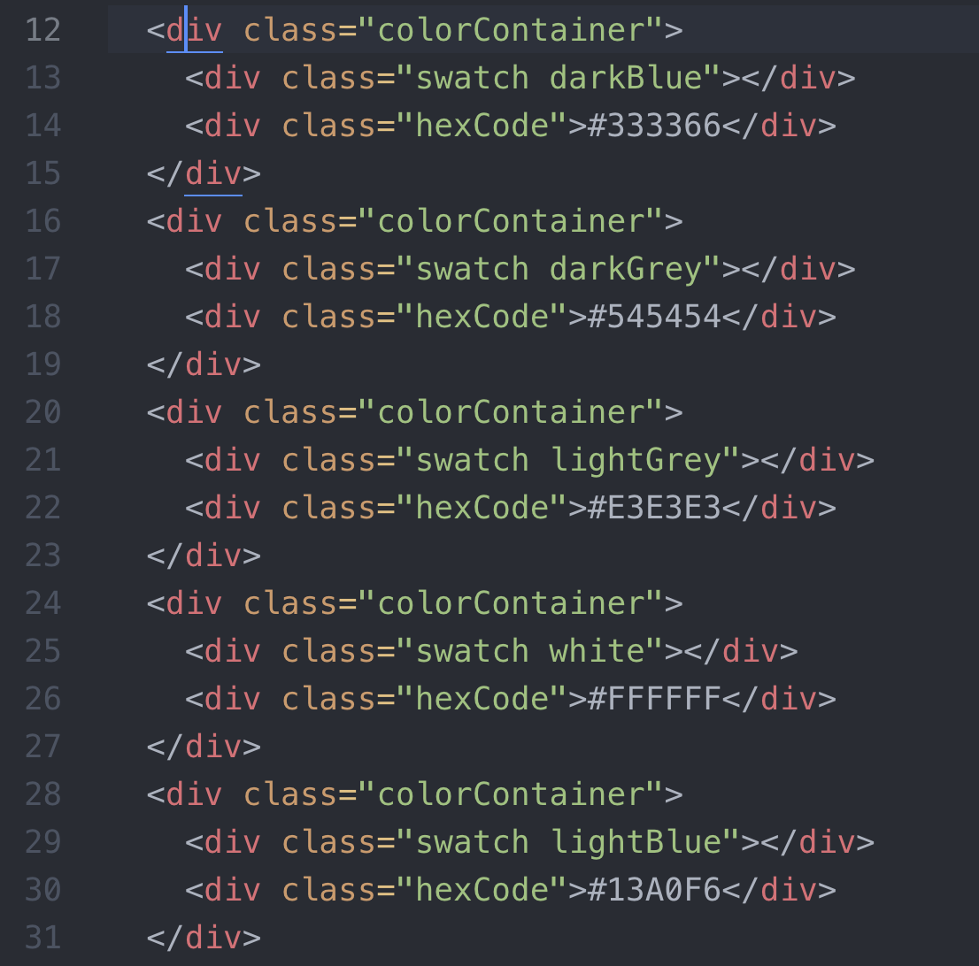

1. Add an <h2> tag with a class of sectionHead.
   * Type “Text Colors” between the opening and closing tags.
2. Repeat Part 2, Step 4 with the following values for the **second** class name in the **first** nested <div> tag, and the following text for the **second** nested <div> tag.

| darkBlue | #333366 |
| --- | --- |
| darkGrey | #545454 |

1. Add an <h2> tag with a class of sectionHead.
   * Type “Alert Colors” between the opening and closing tags.
2. Repeat Part 2, Step 4 with the following values for the **second** class name in the **first** nested <div> tag, and the following text for the **second** nested <div> tag.

| red | #F84848 |
| --- | --- |
| orange | #FC7705 |
| lightBlue | #13A0F6 |
| lightGreen | #8ABE48 |

**Part 3: The typography Section**

1. Inside the typography section, add the following tags and values.
2. Add an <h2> tag with a class of sectionHead.
   * Type “Typography” between the opening and closing tags.
3. Add a <p> tag with “Open Sans” between the opening and closing tags.
4. Add a <div> tag with a class of type_container.
   * Within this <div> tag, add two <p> tags.
   * Add the large and light classes to the first tag with the text “Aa” between the opening and closing tags.
   * Add the text “Light” between the opening and closing tags of the second <p> tag.
5. Repeat Part 3, Step 4 with the following values for the **second** class name in the **first** nested <p> tag, the following text for the **first** nested <p> tag, and following text for the **second** nested <p> tag .

| regular | Aa | Regular |
| --- | --- | --- |
| bold | Aa | Bold |

1. Add an <h1> tag with the following text between the opening and closing tags:
   * “H1 - Open Sans Extrabold - size 50px <br> Line height 70px”
   * You will notice a <br> tag in that text. The <br> tag adds a line break to your text.
2. Add an <h2> tag with the following text between the opening and closing tags:
   * “H2 - Open Sans Bold - size 42px <br> Line height 60px”
3. Add an <h3> tag with the following text between the opening and closing tags:
   * “H3 - Open Sans Bold - size 34px <br> Line height 50px”
4. Add an <h4> tag with the following text between the opening and closing tags:
   * “H4 - Open Sans Bold - size 26px <br> Line height 28px”

**Part 4: The uiElements Section**

1. Add an <h2> tag with a class of sectionHead.
   * Type “UI Elements” between the opening and closing tags.
2. Create a <p> tag with the text “Button” between the opening and closing tags.
3. Add a <div> tag with a class of buttonContain.
   * Inside this <div>, add five <div> tags with the following classes for **each** <div> and the following text **within each** <div>.

| button primary | Primary |
| --- | --- |
| button success | Success |
| button danger | Danger |
| button warning | Warning |
| button info | Info |

1. Add a second <div> tag with a class of buttonContain.
   * Inside this second <div>, add five <div> tags with the following classes for **each** <div> and the following text **within each** <div>.

| button primaryActive | Primary Active |
| --- | --- |
| button successActive | Success Active |
| button dangerActive | Danger Active |
| button warningActive | Warning Active |
| button infoActive | Info Active |

**Part 5: The imagery Section**

1. Add an <h2> tag with a class of sectionHead.
   * Type “Logo” between the opening and closing tags.
2. Add four <img> tags with the following values for **each** src attribute in **each** <img> tag.
   * The src attribute specifies the location of the image needed for the <img> tag.
   * images/Logo-dark.png
   * images/Logo-light.png
   * images/Logo-dark1.png
   * images/Logo-light-1.png

That’s it. Great job! You have now gained proficiency in creating a basic structure that can be modified by CSS.